**LAB 4**

* **Wireframes:**

Wireframes are created for login, registration and home pages.

* Login page:

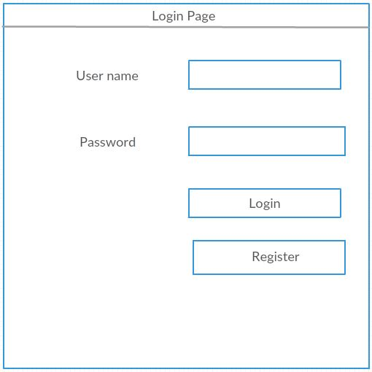

* Registration Page:

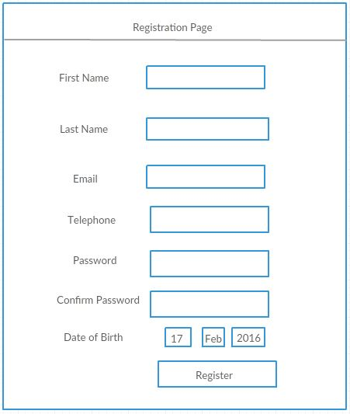

* Home Page:

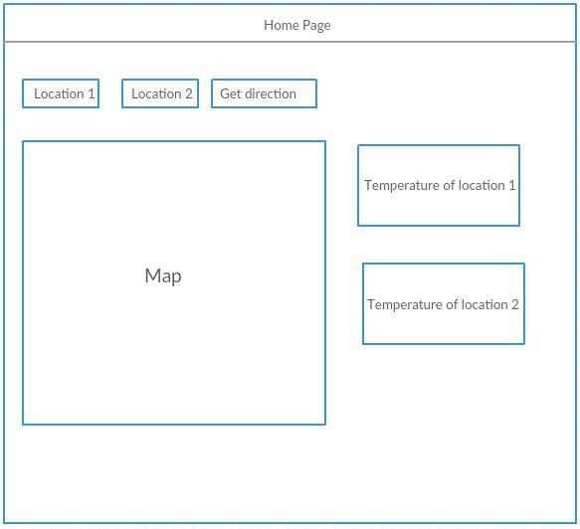

* **WebPages:**
* First page of our application is the login page.

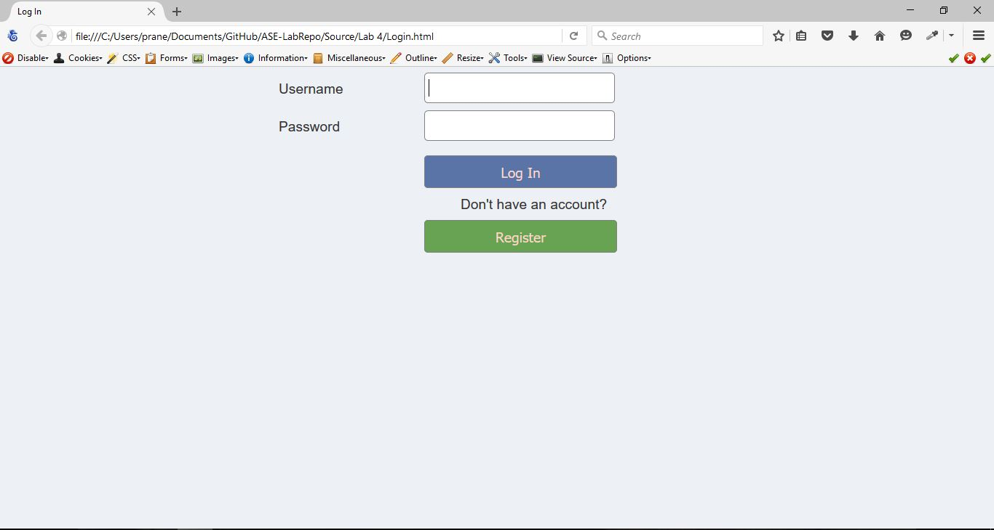

* If the user doesn’t have an account he/she can click the register button and create a profile

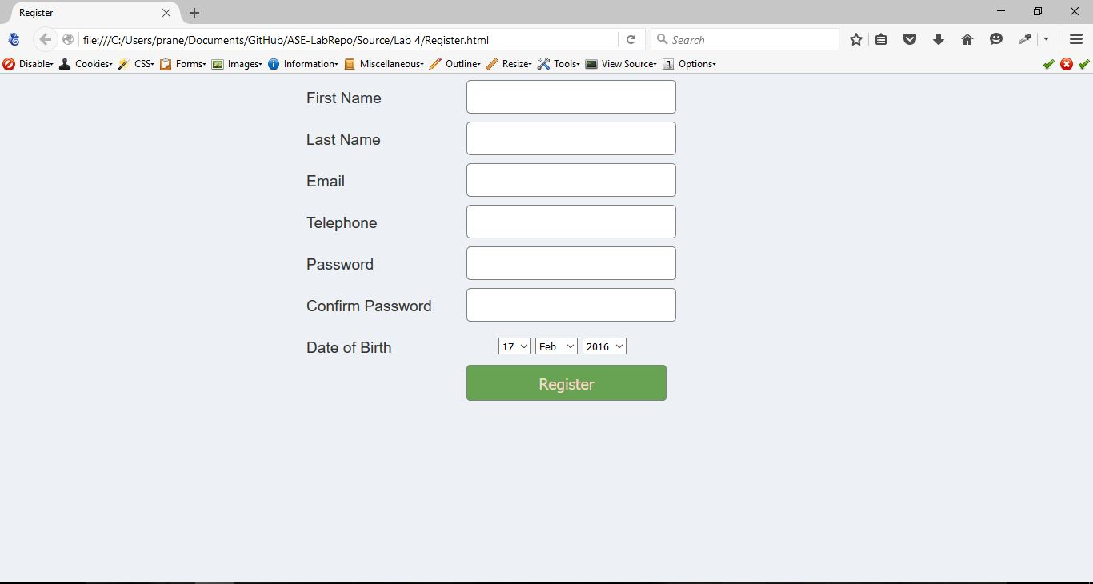

* Now the user can create an account by filling up the appropriate fields. The error messages are popped if the user enters an invalid email ID or phone number.
* Invalid email address:

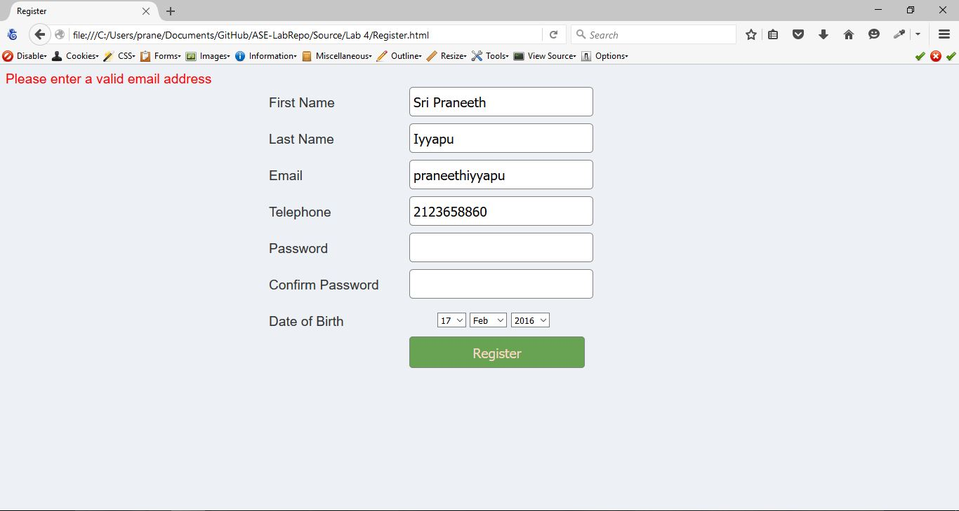

* Invalid phone number:

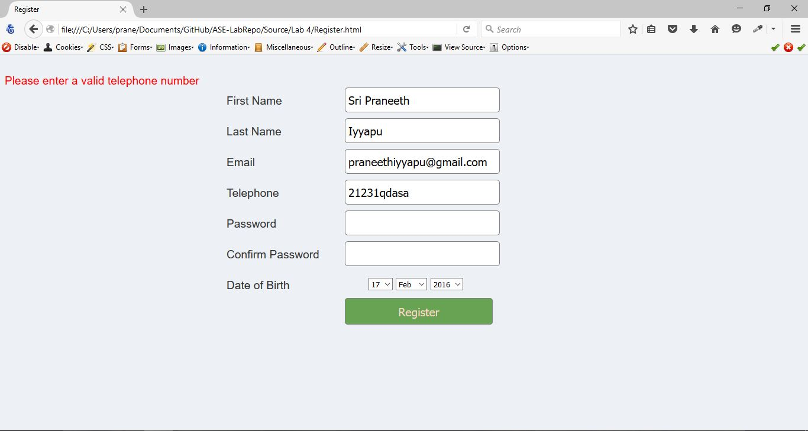

* Error is also thrown when the passwords entered by the user does not match.

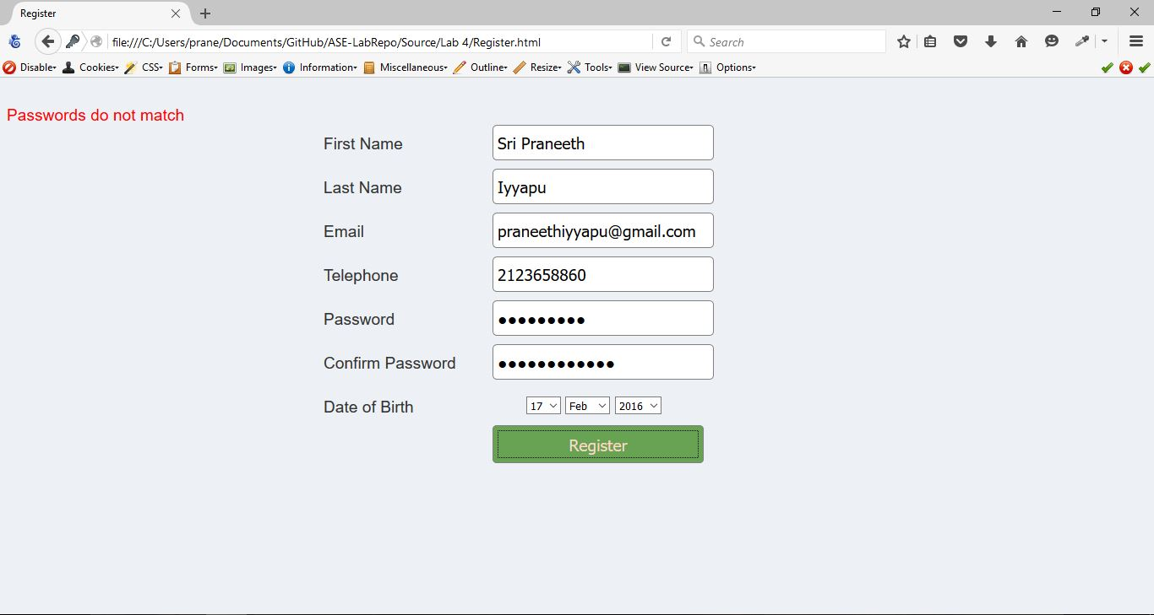

* Once the user enters all the valid details, the registration completes successfully and it redirects back to the log in page.

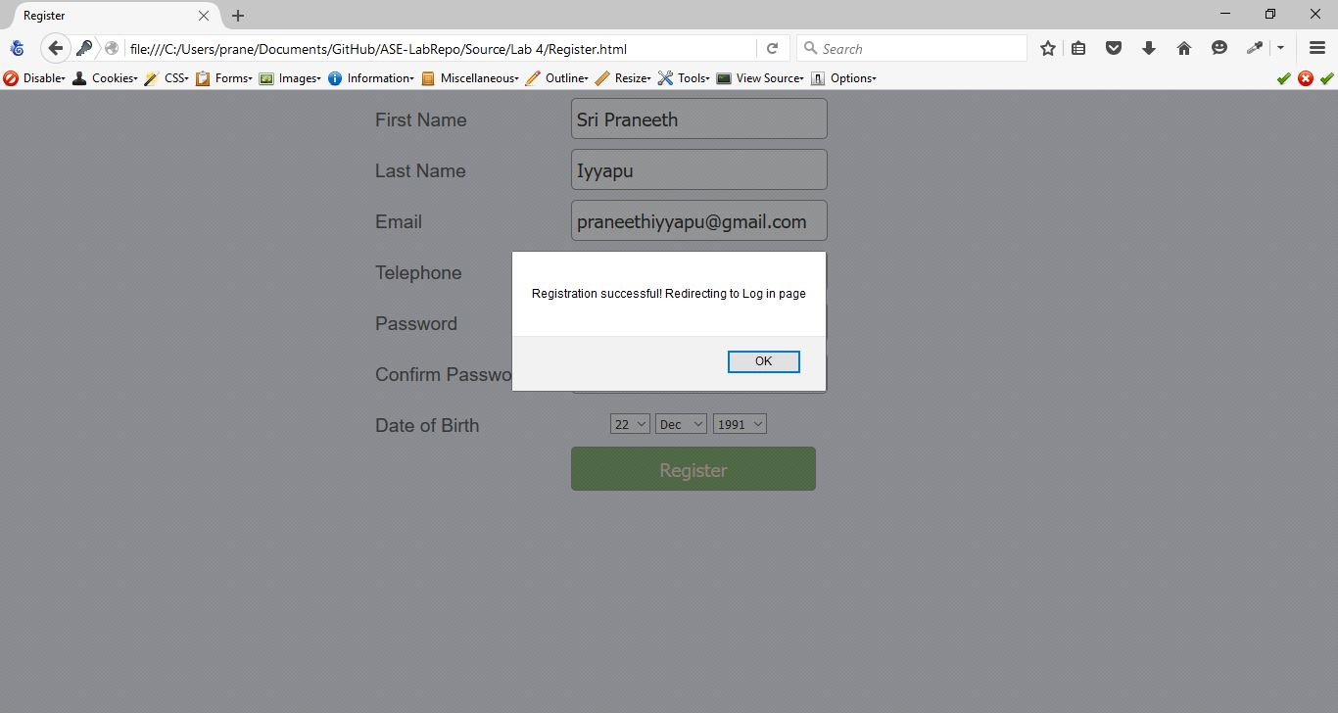

* Redirected back to the login page. If the password or email field is not filled up, an error message is thrown to the user.

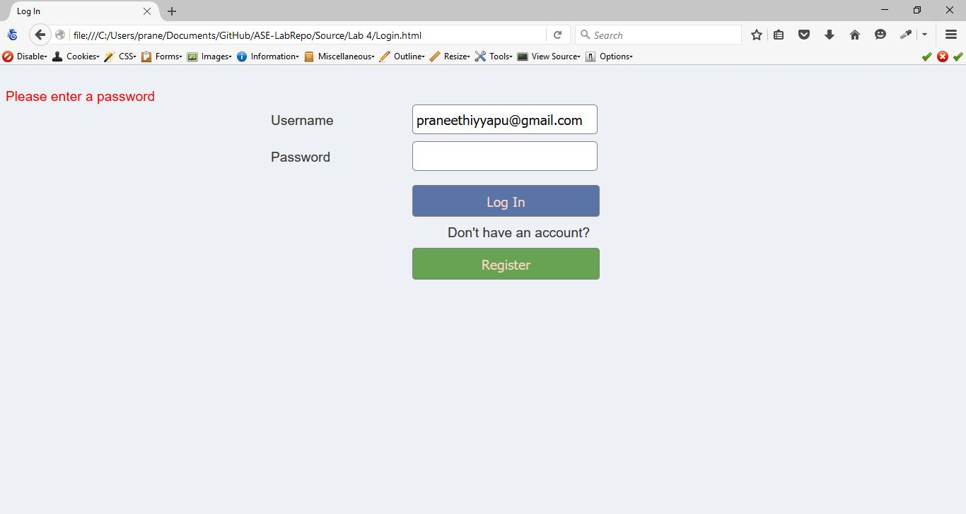

* An error message is also thrown when the username and password does not match

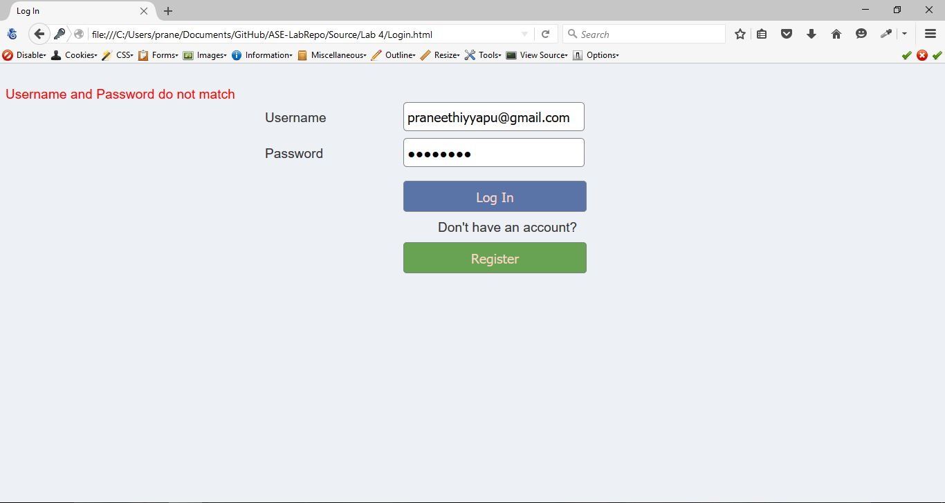

* Once the user inputs correct credentials, it redirects to home page.

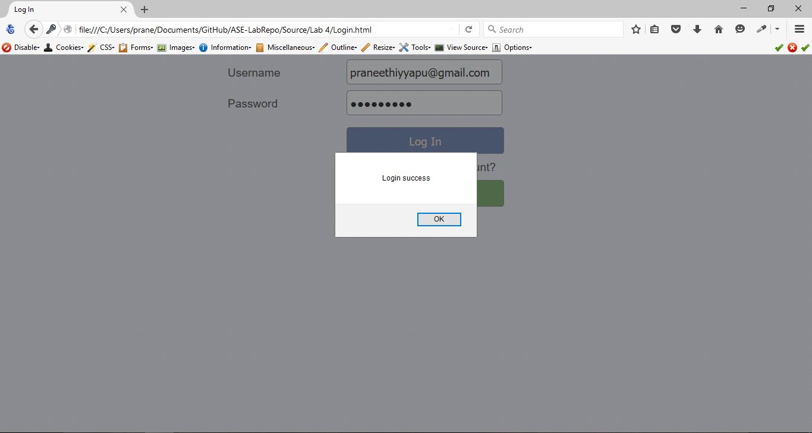

* Redirected to home page

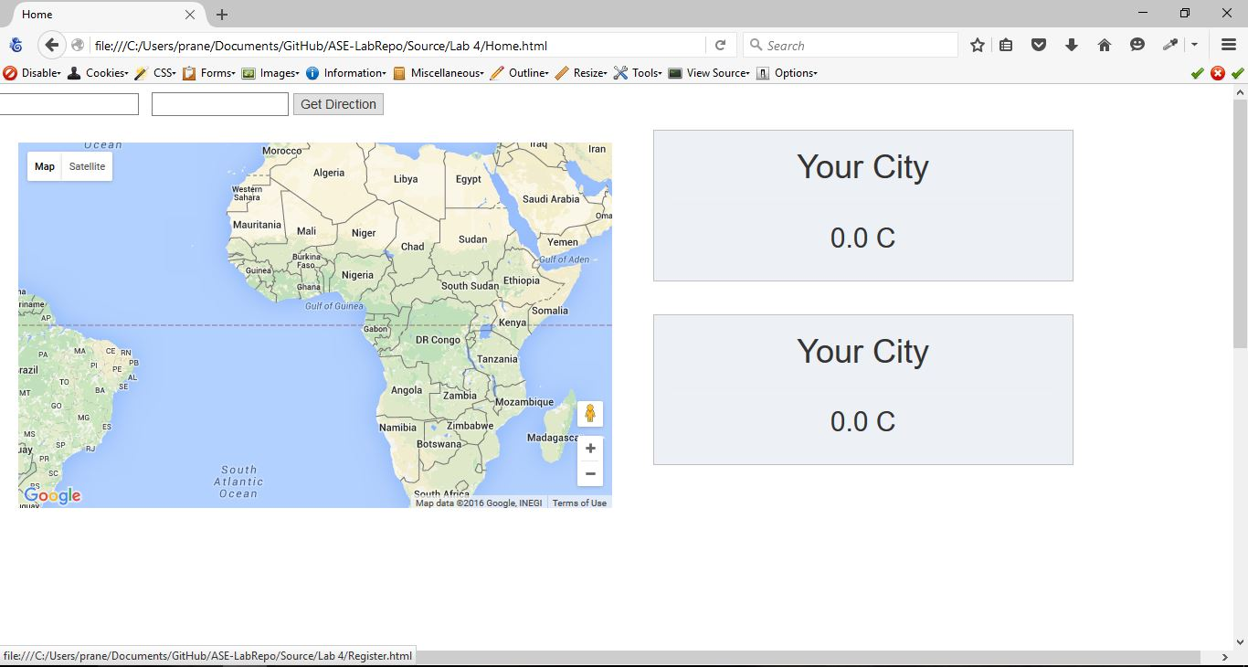

* Once we give the starting and ending locations and click the get directions button a route is shown between the two locations. We also get current weather of both the places.

